#### **1.What does an empty dictionary's code look like?**

**Ans:** An empty dictionary is often represented by two empty curly brackets

d = {} or d = dict()

#### **2.what is the value of dictionary value with key 'foo' and the value 42 ?**

**Ans:** {'foo':42}

#### **3.What is the most significant distinction between a dictionary and a list?**

**Ans:** Dictionaries are represented by {} where as listed are represented by []

The Items stored in a dictionary are Unordered , while the items in a list are ordered

#### **4.What happens if you try to access spam ['foo'] if spam is {'bar':100} ?**

**Ans:** we will get a keyError KeyError: 'foo'

#### **5.if a dictionary is stored in spam,what is the difference between the expressions 'cat' in spam and 'cat' in spam.keys() ?**

**Ans:** There is no difference . The operator checks whether a value exits as a key in the dictionary or not

#### **6.if a dictionary is stored in spam,what is the difference between the expressions 'cat' in spam and 'cat' in spam.values() ?**

**Ans:**'cat' in spam checks whether there is a 'cat' key in the dictionary, while 'cat' in spam.values() checks whether there is a value 'cat' for one of the keys in spam.

#### **7.what is a shortcut for the following code ?**

if 'color' not in spam:

spam['color'] ='black'

**Ans:** spam.setdefault('color','black')

#### **8.How do you 'pretty print' dictionary values using which modules and function ?**

**Ans:** we can pretty print a dictionary using three functions

1. by using pprint() function of pprint module
   * **Note:** pprint() function doesnot prettify nested dictionaries
2. by using dumps() method of json module
3. by using dumps() method of yaml module

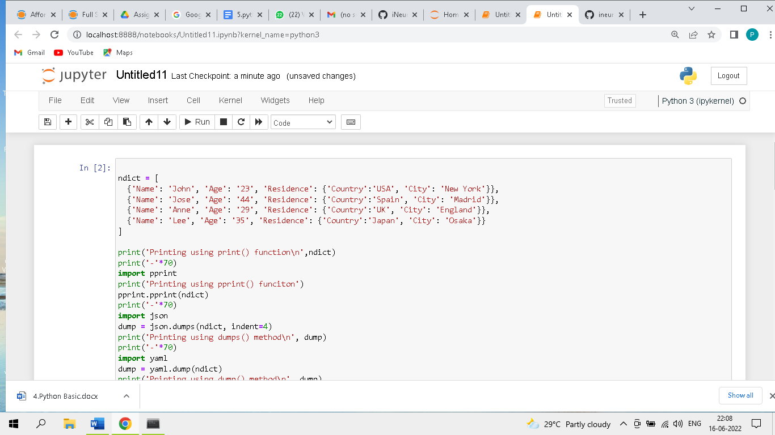

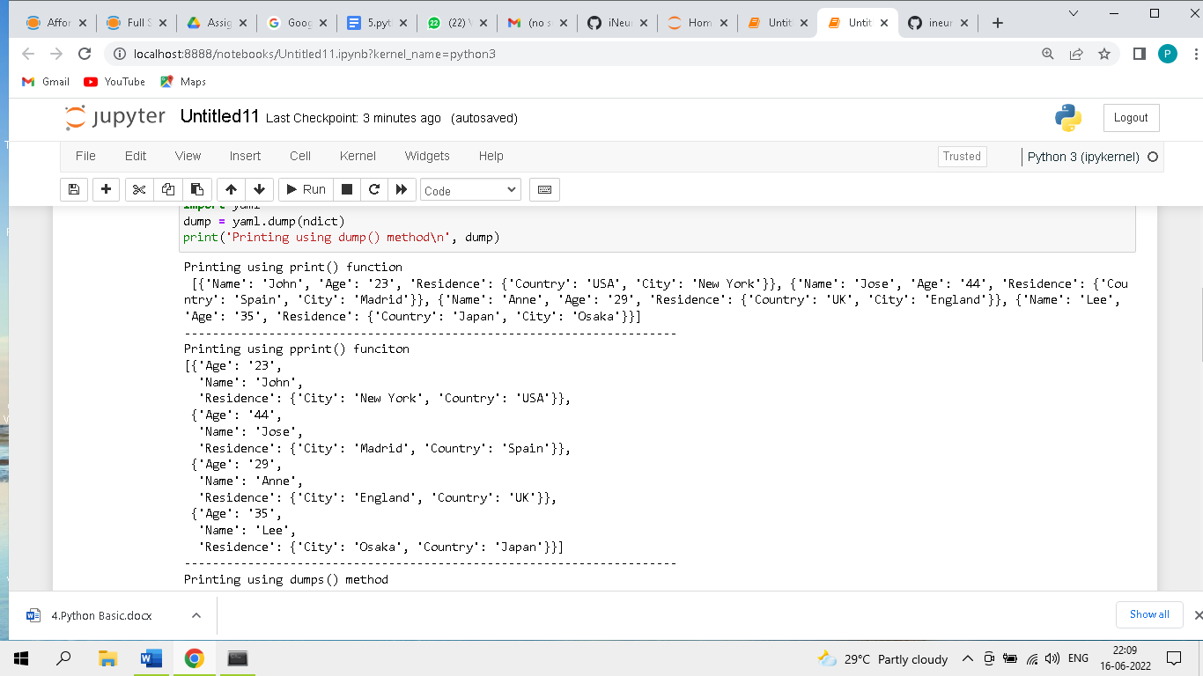

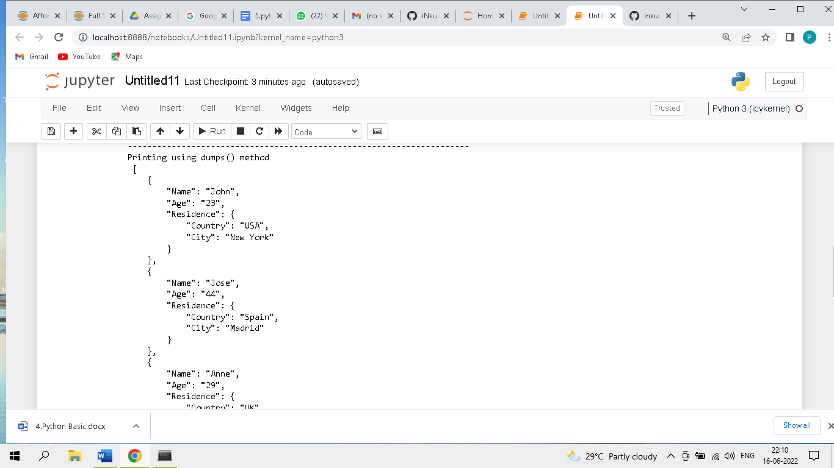

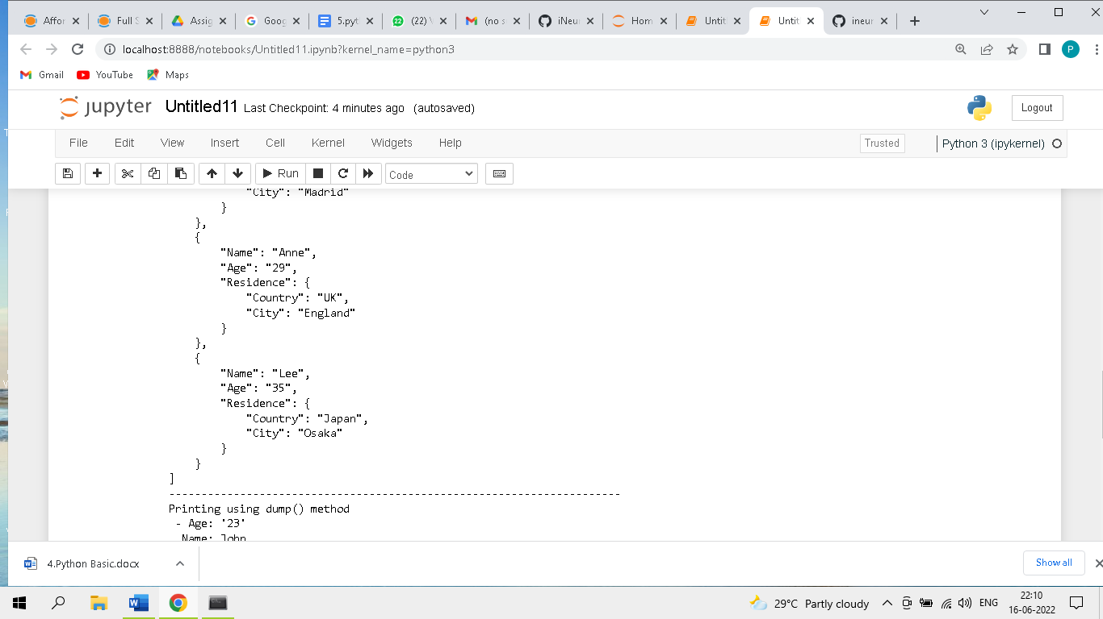

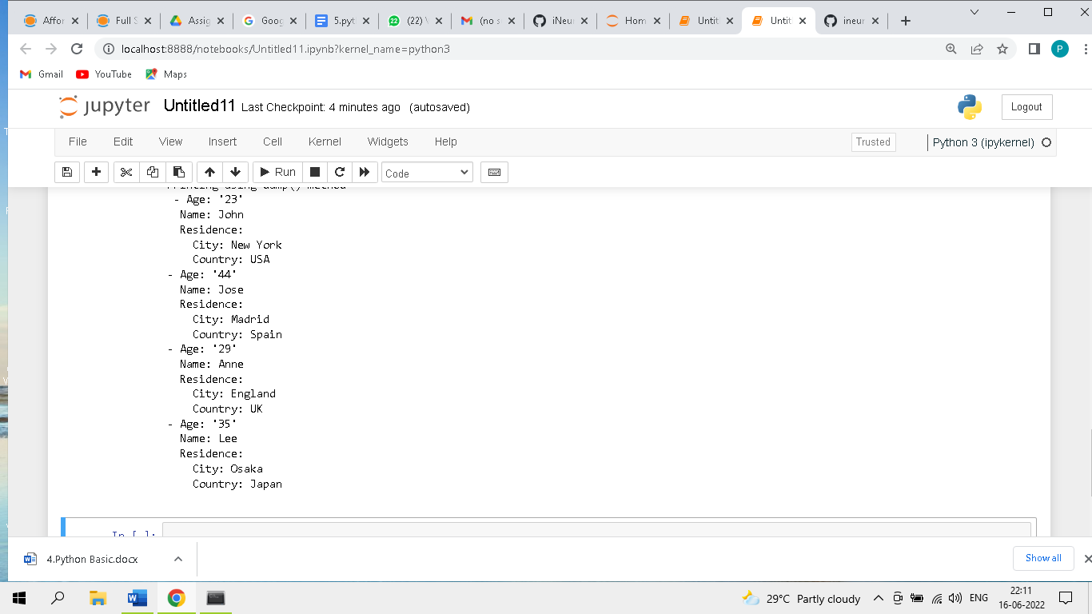

ndict = [

{'Name': 'John', 'Age': '23', 'Residence': {'Country':'USA', 'City': 'New York'}},

{'Name': 'Jose', 'Age': '44', 'Residence': {'Country':'Spain', 'City': 'Madrid'}},

{'Name': 'Anne', 'Age': '29', 'Residence': {'Country':'UK', 'City': 'England'}},

{'Name': 'Lee', 'Age': '35', 'Residence': {'Country':'Japan', 'City': 'Osaka'}}

]

print('Printing using print() function\n',ndict)

print('-'*70)

import pprint

print('Printing using pprint() funciton')

pprint.pprint(ndict)

print('-'*70)

import json

dump = json.dumps(ndict, indent=4)

print('Printing using dumps() method\n', dump)

print('-'*70)

import yaml

dump = yaml.dump(ndict)

print('Printing using dump() method\n', dump)

Output:

Printing using print() function

[{'Name': 'John', 'Age': '23', 'Residence': {'Country': 'USA', 'City': 'New York'}}, {'Name': 'Jose', 'Age': '44', 'Residence': {'Country': 'Spain', 'City': 'Madrid'}}, {'Name': 'Anne', 'Age': '29', 'Residence': {'Country': 'UK', 'City': 'England'}}, {'Name': 'Lee', 'Age': '35', 'Residence': {'Country': 'Japan', 'City': 'Osaka'}}]

----------------------------------------------------------------------

Printing using pprint() funciton

[{'Age': '23',

'Name': 'John',

'Residence': {'City': 'New York', 'Country': 'USA'}},

{'Age': '44',

'Name': 'Jose',

'Residence': {'City': 'Madrid', 'Country': 'Spain'}},

{'Age': '29',

'Name': 'Anne',

'Residence': {'City': 'England', 'Country': 'UK'}},

{'Age': '35',

'Name': 'Lee',

'Residence': {'City': 'Osaka', 'Country': 'Japan'}}]

----------------------------------------------------------------------

Printing using dumps() method

[

{

"Name": "John",

"Age": "23",

"Residence": {

"Country": "USA",

"City": "New York"

}

},

{

"Name": "Jose",

"Age": "44",

"Residence": {

"Country": "Spain",

"City": "Madrid"

}

},

{

"Name": "Anne",

"Age": "29",

"Residence": {

"Country": "UK",

"City": "England"

}

},

{

"Name": "Lee",

"Age": "35",

"Residence": {

"Country": "Japan",

"City": "Osaka"

}

}

]

----------------------------------------------------------------------

Printing using dump() method

- Age: '23'

Name: John

Residence:

City: New York

Country: USA

- Age: '44'

Name: Jose

Residence:

City: Madrid

Country: Spain

- Age: '29'

Name: Anne

Residence:

City: England

Country: UK

- Age: '35'

Name: Lee

Residence:

City: Osaka

Country: Japan

​